A Project Stage-2 Report on

**Modelling and simulation of solid oxide fuel cell**

By

Mr. Suyash Aher Mr. Amol Bhokare

Mr. Omkar Bhor Mr. Shubham Sawant

Guide

Prof. Ganesh Kerkal



Department of Mechanical Engineering

Dr. D. Y. Patil Institute of Engineering, Management & Research, Akurdi

[2020-21]

Dr. D. Y. Patil Institute of Engineering, Management & Research, Akurdi



C E R T I F I C A T E

This is to certify that Mr. Suyash Aher, Mr. Amol Bhokare, Mr.Omkar Bhor, Mr.Shubham Sawant has successfully completed the project Stage-2 entitled “Modelling and simulation of solid oxide fuel cell” under my supervision, in the partial fulfilment of Bachelor of Engineering – Mechanical Engineering of University of Pune.

Date:11/06/2021

Place: Pune

Prof. Ganesh Kerkal

Guide

Prof.Dr. Sunil Dambhare Dr.AnupamaPatil

Head of the department Principal

**Abstract**

As in today’s world, where there are energy crisis and therefore the resources are depleting at a better rate, there’s a requirement of specific technology that recovers the energy, which gets usually wasted.A Solid Oxide Fuel Cell (SOFC) is typically composed of two porous electrodes, interposed between an electrolyte made of a particular solid oxide ceramic material. The system originates from the work of Nernst in the nineteenth century. In his patent, Nernst proposed that a solid electrolyte could be made to electrically conduct, using a heater; the system then “glowed” by the passage of an electric current. The systems originally studied by Nernst were based on simple metal oxides. In 1937, Bauer and Preisoperated the first ceramic fuel cell at 1000°C, showing that the so-called “Nernst Mass” (85% zirconia and 15% yttria), and other zirconia-based materials present a reasonable ionic conduction at high temperature (600–1000°C). This paper presents a review of studies on mathematical modeling of solid oxide fuel cells.Fuel cells are known for their reliability, power quality, eco-friendly nature and fuel efficiency. Its promising technology and extremely significant in the near future.

This paper deals with the study of dynamic model of solid oxide fuel cell (SOFC) based on transfer function. The studied model includes the effect of activation, ohmic and concentration losses on the dynamic performances of SOFC. The performance of the model is tested for constant utilization mode and constant fuel flow mode of operations.The effect of varying operating temperature on the performance of SOFC is also analyzed .

**Keywords** : Solid oxide fuel cell, mathematical modelling, ohmic losses, Activation losses

**CONTENTS**

|  |  |  |  |
| --- | --- | --- | --- |
| **CH NO** | **SUB CH NO** | **TITLE** | **PAGE NO** |
| 1 |  | Introduction | 7 |
|  | 1.1 | Problem Statement | 16 |
|  | 1.2 | Construction and Working | 17 |
|  | 1.3 | Objective | 18 |
|  | 1.4 | Scope | 18 |
|  | 1.5 | Methodology | 19 |
| 2 |  | Literature Review | 20 |
| 3 |  | Mathematical Modelling | 31 |
| 4 |  | Results and Discussion | 35 |
| 5 |  | Validation | 40 |
| 6 |  | Conclusion and Future Scope | 41 |

|  |  |  |
| --- | --- | --- |
| **Sr No** | **List of figures** | **Page no** |
| 1 | Sketch of Sir William Groves 1839 Fuel Cell | 7 |
| 2 | General Construction of Fuel Cell | 9 |
| 3 | Proton Exchange Membrane Fuel Cell | 10 |
| 4 | Polymer Electrolyte Membrane Fuel Cell | 11 |
| 5 | Direct Methanol Fuel Cell | 12 |
| 6 | Molten Carbonate Fuel Cell | 13 |
| 7 | Solid Oxide Fuel Cell | 14 |
| 8 | Construction Of Solid Oxide Fuel Cell | 17 |
| 9 | Working Of Solid Oxide Fuel Cell | 17 |
| 10 | System Inputs and Outputs | 19 |
| 11 | Simulated Temperature-Voltage Behaviour | 35 |
| 12 | Simulated Temperature-Activation Loss Behaviour | 35 |
| 13 | Simulated Temperature-Concentration Loss Behaviour | 36 |
| 14 | Simulated Temperature-Ohmic Loss Behaviour | 36 |
| 15 | Simulated Temperature-Output Voltage Behaviour | 37 |
| 16 | Simulated Temperature-Power Behaviour | 37 |

|  |  |  |
| --- | --- | --- |
| **Sr no** | **List of tables** | **Page No** |
| 1 | Temperature-Voltage Outcomes | 35 |
| 2 | Temperature-Activation Loss Outcomes | 35 |
| 3 | Temperature-Concentration Loss Outcomes | 36 |
| 4 | Temperature-Ohmic Loss Outcomes | 36 |
| 5 | Temperature-Output Voltage Outcomes | 37 |
| 6 | Temperature-Power Outcomes | 37 |
| 7 | Overall Result For Fuel Flow Rate 25ml/sec. | 38 |
| 8 | Overall Result For Fuel Flow Rate 50ml/sec. | 38 |
| 9 | Overall Result For Fuel Flow Rate 75ml/sec. | 39 |
| 10 | Validation Of Results | 40 |

**CHAPTER 1**

**INTRODUCTION**

A fuel cell is an electrochemical cell that converts the chemical energy of a fuel (often hydrogen) and an oxidizing agent (often oxygen[1]) into electricity through a pair of redox reactions.[2] Fuel cells are different from most batteries in requiring a continuous source of fuel and oxygen (usually from air) to sustain the chemical reaction, whereas in a battery the chemical energy usually comes from metals and their ions or oxides[3] that are commonly already present in the battery, except inflow batteries. Fuel cells can produce electricity continuously for as long as fuel and oxygen are supplied.

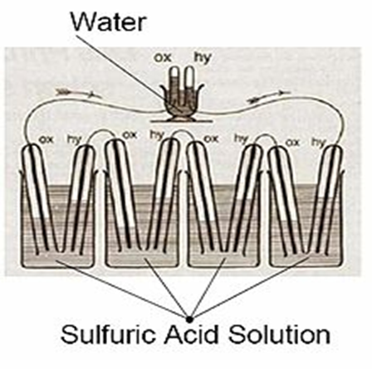

Sketch of Sir William Groves 1839 Fuel Cell

Fig. (1)

The first references to hydrogen fuel cells appeared in 1838. In a letter dated October 1838 but published in the December 1838 edition of The London and Edinburgh Philosophical Magazine and Journal of Science, Welsh physicist and barrister Sir William Grove wrote about the development of his first crude fuel cells. He used a combination of sheet iron, copper and porcelain plates, and a solution of sulphate of copper and dilute acid.[4][5] In a letter to the same publication written in December 1838 but published in June 1839, German physicist Christian Friedrich Schönbein discussed the first crude fuel cell that he had invented. His letter discussed current generated from hydrogen and oxygen dissolved in water.[6] Grove later sketched his design, in 1842, in the same journal. The fuel cell he made used similar materials to today's phosphoric acid fuel cell.[7][8]

In 1932, English engineer Francis Thomas Bacon successfully developed a 5 kW stationary fuel cell.[9] The alkaline fuel cell (AFC), also known as the Bacon fuel cell after its inventor, is one of the most developed fuel cell technologies, which NASA has used since the mid-1960s.[9]

In 1955, W. Thomas Grubb, a chemist working for the General Electric Company (GE), further modified the original fuel cell design by using a sulphonated polystyrene ion-exchange membrane as the electrolyte. Three years later another GE chemist, Leonard Niedrach, devised a way of depositing platinum onto the membrane, which served as catalyst for the necessary hydrogen oxidation and oxygen reduction reactions. This became known as the "Grubb-Niedrach fuel cell".[10][11] GE went on to develop this technology with NASA and McDonnell Aircraft, leading to its use during Project Gemini. This was the first commercial use of a fuel cell. In 1959, a team led by Harry Ihrig built a 15 kW fuel cell tractor for Allis-Chalmers, which was demonstrated across the U.S. at state fairs. This system used potassium hydroxide as the electrolyte and compressed hydrogen and oxygen as the reactants. Later in 1959, Bacon and his colleagues demonstrated a practical five-kilowatt unit capable of powering a welding machine

In the 1960s, Pratt & Whitney licensed Bacon's U.S. patents for use in the U.S. space program to supply electricity and drinking water (hydrogen and oxygen being readily available from the spacecraft tanks). In 1991, the first hydrogen fuel cell automobile was developed by Roger Billings.[12]

UTC Power was the first company to manufacture and commercialize a large, stationary fuel cell system for use as a co-generation power plant in hospitals, universities and large office buildings.[13]

Types of Fuel Cells:

Fuel cells come in many varieties; however, they all work in the same general manner. They are made up of three adjacent segments: the anode, the electrolyte, and the cathode. Two chemical reactions occur at the interfaces of the three different segments. The net result of the two reactions is that fuel is consumed, water or carbon dioxide is created, and an electric current is created, which can be used to power electrical devices, normally referred to as the load.

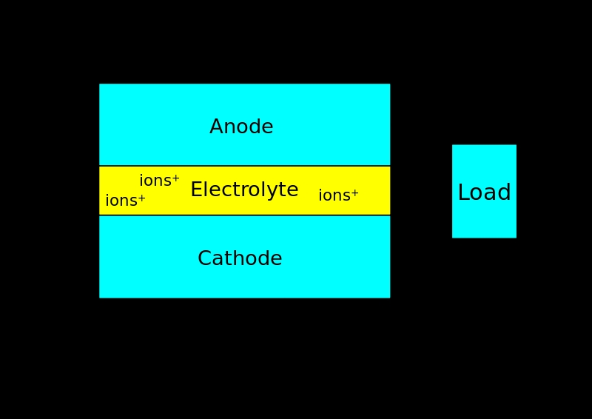

Fig.(2)

**A) Proton Exchange Membrane Fuel Cell**

In the archetypical hydrogen–oxide proton-exchange membrane fuel cell design, a proton-conducting polymer membrane (typically nafion) contains the electrolyte solution that separates the anode and cathode sides.[14][15] This was called a solid polymer electrolyte fuel cell (SPEFC) in the early 1970s, before the proton-exchange mechanism was well understood. (Notice that the synonyms polymer electrolyte membrane and 'proton-exchange mechanism result in the same acronym.)

On the anode side, hydrogen diffuses to the anode catalyst where it later dissociates into protons and electrons. These protons often react with oxidants causing them to become what are commonly referred to as multi-facilitated proton membranes. The protons are conducted through the membrane to the cathode, but the electrons are forced to travel in an external circuit (supplying power) because the membrane is electrically insulating. On the cathode catalyst, oxygen molecules react with the electrons (which have traveled through the external circuit) and protons to form water.

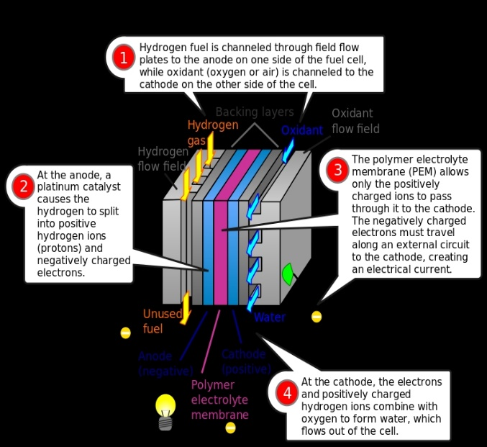

Proton Exchange Membrane Fuel Cell

Fig.(3)

In addition to this pure hydrogen type, there are hydrocarbon fuels for fuel cells, including diesel, methanol (see: direct-methanol fuel cells and indirect methanol fuel cells) and chemical hydrides. The waste products with these types of fuel are carbon dioxide and water. When hydrogen is used, the CO2 is released when methane from natural gas is combined with steam, in a process called steam methane reforming, to produce the hydrogen. This can take place in a different location to the fuel cell, potentially allowing the hydrogen fuel cell to be used indoors—for example, in fork lift.

Limitations of PEMFC-

1. Cost is high. Many companies are working on techniques to reduce cost in a variety of ways including reducing the amount of platinum needed in each individual cell. Ballard Power Systems has experimented with a catalyst enhanced with carbon silk, which allows a 30% reduction in platinum usage without reduction in performance.[16]

2. Water and air management is hard to keep up with.In this type of fuel cell, the membrane must be hydrated, requiring water to be evaporated at precisely the same rate that it is produced. If water is evaporated too quickly, the membrane dries, resistance across it increases, and eventually it will crack, creating a gas "short circuit"

Applications-

The major application of PEM fuel cells focuses on transportation primarily .Other applications include distributed/stationary and portable power generation. Most major motor companies work solely on PEM fuel cells due to their high power density and excellent dynamic characteristics as compared with other types of fuel cells.[17] Due to their light weight, PEMFCs are most suited for transportation applications. PEMFCs for buses, which use compressed hydrogen for fuel, can operate at up to 40% efficiency.

#### **B)Polymer Electrolyte Membrane Fuel Cell**

Polymer electrolyte membrane (PEM) fuel cells—also called proton exchange membrane fuel cells—deliver high power density and offer the advantages of low weight and volume compared with other fuel cells. PEM fuel cells use a solid polymer as an electrolyte and porous carbon electrodes containing a platinum or platinum alloy catalyst. They need only hydrogen, oxygen from the air, and water to operate. They are typically fueled with pure hydrogen supplied from storage tanks or reformers.

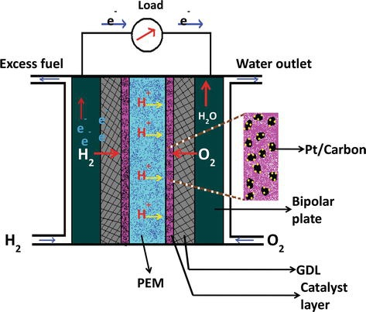

Polymer Electrolyte Membrane Fuel Cell

Fig.(4)

PEM fuel cells are used primarily for transportation applications and some stationary applications. Due to their fast startup time and favorable power-to-weight ratio, PEM fuel cells are particularly suitable for use in passenger vehicles, such as cars and buses.[19]

Advantage of Polymer Electrolyte Fuel Cell

1. Good Mechanical strength (operating conditions)
2. Good Thermal stability
3. High Stability in oxidative & reductive environment
4. Good Chemical & Electrochemical Stability

#### **C)Direct Methanol Fuel Cell**

Most fuel cells are powered by hydrogen, which can be fed to the fuel cell system directly or can be generated within the fuel cell system by reforming hydrogen-rich fuels such as methanol, ethanol, and hydrocarbon fuels. Direct methanol fuel cells (DMFCs), however, are powered by pure methanol, which is usually mixed with water and fed directly to the fuel cell anode.

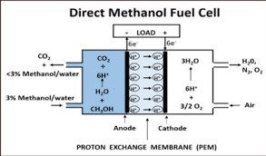

Direct Methanol Fuel Cell

Fig. (5)

Direct methanol fuel cells do not have many of the fuel storage problems typical of some fuel cell systems because methanol has a higher energy density than hydrogen—though less than gasoline or diesel fuel. Methanol is also easier to transport and supply to the public using our current infrastructure because it is a liquid, like gasoline. DMFCs are often used to provide power for portable fuel cell applications such as cell phones or laptop computers.

#### **D)Molten Carbonate Fuel Cells**

Molten carbonate fuel cells (MCFCs) are currently being developed for natural gas and coal-based power plants for electrical utility, industrial, and military applications. MCFCs are high-temperature fuel cells that use an electrolyte composed of a molten carbonate salt mixture suspended in a porous, chemically inert ceramic lithium aluminum oxide matrix. Because they operate at high temperatures of 650°C (roughly 1,200°F), non-precious metals can be used as catalysts at the anode and cathode, reducing costs.[18]

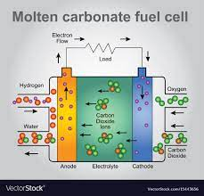

Fig. (6)

Advantage of Molten Carbonate Fuel Cell:

MCFCs are also highly efficient, achieving approximately 50% efficiency where waste heat is not captured and 85% efficiency when it is.

Because they do not contain platinum catalysts they are not susceptible to carbon monoxide or carbon dioxide poisoning. In fact, they can use carbon dioxide as fuel. This fact makes them very attractive for energy production in countries like the United States that have large natural reserves of coal.

Disadvantage of Molten Carbonate Fuel Cell:

The other drawback to MFCFs is their susceptibility to poisoning by sulfur, which is found at high concentration in many types of coal. This problem is currently addressed with the use of sulfur absorption, which requires frequent changing of components.[18]

The other major drawback to MCFCs is that they use hydrocarbon fuels. While this may be seen as an advantage in terms of supply and production over hydrogen, it is a tremendous disadvantage in terms of greenhouse gas emissions and, in the case of coal, acid rain producing sulfur emissions.

**E)Solid Oxide Fuel Cell**

Solid oxide fuel cells are a class of fuel cells characterized by the use of a solid oxidematerial as the electrolyte. SOFCs use a solid oxide electrolyte to conduct negative oxygen ions from the cathode to the anode. The electrochemical oxidation of the hydrogen carbon monoxide or other organic intermediates by oxygen ions thus occurs on theside anode.

Solid oxide fuel cells have a wide variety of applications, from use as auxiliary power units in vehicles to stationary power generation with outputs from 100 W to 2 MW. In 2009, Australian company, Ceramic Fuel Cells successfully achieved an efficiency of an SOFC device up to the previously theoretical mark of 60%. The higher operating temperature make SOFCs suitable candidates for application with heat engine energy recovery devices or combined heat and power, which further increases overall fuel efficiency.

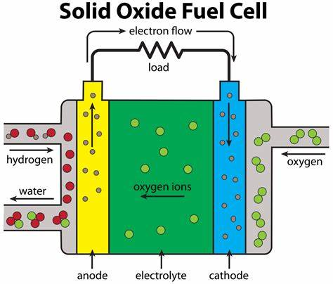

Fig. (7)

Because of these high temperatures, light hydrocarbon fuels, such as methane, propane, and butane can be internally reformed within the anode. SOFCs can also be fueled by externally reforming heavier hydrocarbons, such as gasoline, diesel, jet fuel (JP-8) or biofuels. Such reformates are mixtures of hydrogen, carbon monoxide, carbon dioxide, steam and methane, formed by reacting the hydrocarbon fuels with air or steam in a device upstream of the SOFC anode. SOFC power systems can increase efficiency by using the heat given off by the exothermic electrochemical oxidation within the fuel cell for endothermic steam reforming process.

Thermal expansion demands a uniform and well-regulated heating process at startup. SOFC stacks with planar geometry require on the order of an hour to be heated to operating temperature. Micro-tubular fuel cell design geometries promise much faster start up times, typically in the order of minutes.

Researchers around the world are making a concerted effort in the development of suitable materials and ceramic structures, which are currently the key technical challenges facing SOFCs. Simple ceramic processes have to be developed so that [thin-film](https://www.sciencedirect.com/topics/materials-science/thin-films) electrolytes that decrease the cell resistance can be used. This improvement doubles the power output and significantly reduces the cost of SOFCs. Global companies making SOFCs continue to realize very significant improvements in basic fuel-cell design. Higher power densities contribute to lower weight, size and cost of fuel cell systems. SOFCs could be soon suitable for small-scale residential market applications, if ultimate cost goals of $1000/kW are reached.

Unlike most other types of fuel cells, SOFCs can have multiple geometries. The planar fuel cell design geometry is the typical sandwich type geometry employed by most types of fuel cells, where the electrolyte is sandwiched in between the electrodes. SOFCs can also be made in tubular geometries where either air or fuel is passed through the inside of the tube and the other gas is passed along the outside of the tube. The tubular design is advantageous because it is much easier to seal air from the fuel. The performance of the planar design is currently better than the performance of the tubular design, however, because the planar design has a lower resistance comparatively. Other geometries of SOFCs include modified planar fuel cell designs (MPC or MPSOFC), where a wave-like structure replaces the traditional flat configuration of the planar cell. Such designs are highly promising because they share the advantages of both planar cells (low resistance) and tubular cells.

In the archetypical hydrogen–oxide proton-exchange membrane fuel cell design, a proton-conducting polymer membrane (typically nafion) contains the electrolyte solution that separates the anode and cathode sides.[26][27] This was called a solid polymer electrolyte fuel cell (SPEFC) in the early 1970s, before the proton-exchange mechanism was well understood. (Notice that the synonyms polymer electrolyte membrane and 'proton-exchange mechanism result in the same acronym.)

On the anode side, hydrogen diffuses to the anode catalyst where it later dissociates into protons and electrons. These protons often react with oxidants causing them to become what are commonly referred to as multi-facilitated proton membranes. The protons are conducted through the membrane to the cathode, but the electrons are forced to travel in an external circuit (supplying power) because the membrane is electrically insulating. On the cathode catalyst, oxygen molecules react with the electrons (which have traveled through the external circuit) and protons to form water.

In addition to this pure hydrogen type, there are hydrocarbon fuels for fuel cells, including diesel, methanol (see: direct-methanol fuel cells and indirect methanol fuel cells) and chemical hydrides. The waste products with these types of fuel are carbon dioxide and water. When hydrogen is used, the CO2 is released when methane from natural gas is combined with steam, in a process called steam methane reforming, to produce the hydrogen. This can take place in a different location to the fuel cell, potentially allowing the hydrogen fuel cell to be used indoors—for example, in fork lifts.

Applications**-**

The major application of PEM fuel cells focuses on transportation primarily .Other applications include distributed/stationary and portable power generation. Most major motor companies work solely on PEM fuel cells due to their high power density and excellent dynamic characteristics as compared with other types of fuel cells.[43] Due to their light weight, PEMFCs are most suited for transportation applications. PEMFCs for buses, which use compressed hydrogen for fuel, can operate at up to 40% efficiency

**1.1Problem Statement**

At this Century, the demand for electricity is growing daily and the graph is gradually increasing. After Some Years there will be shortage of electricity or less energy is will created so to overcome these problems different techniques are used to create the voltage. More efficient, less emission cell is in research in which one of the is Solid Oxide Fuel Cell. By considering different parameters we are simulating a fuel cell by using Nernst equation. Losses in Cells are calculated with the help of Python. Factors Affecting to the cell and how eliminate or reduce them are in search by changing size of anode, cathode, electrolyte, Interconnector. To overcome this problem Program on Python is created.

**1.2 Construction and Working**

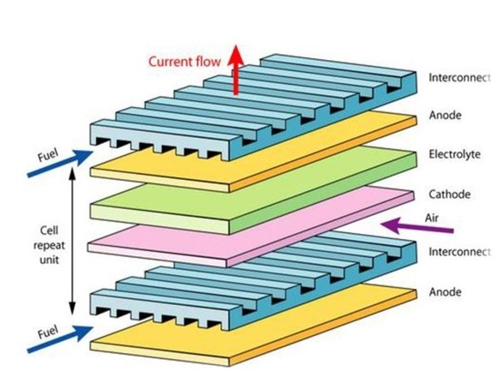

Construction of SOFC

Fig. (8)

Anode: Materials**-**Nickel oxides with zirconia based coatings ,Vanadium oxide

Cathode: Materials**-**Lanthanum manganite doped with alkaline elements.

Electrolyte: Materials-Yttria stabilized zirconia (YSZ), rare earth doped ceria, and rare earth doped bismuth oxide.

Interconnect: Materials-Doped lanthanum chromite which is p type conductor.

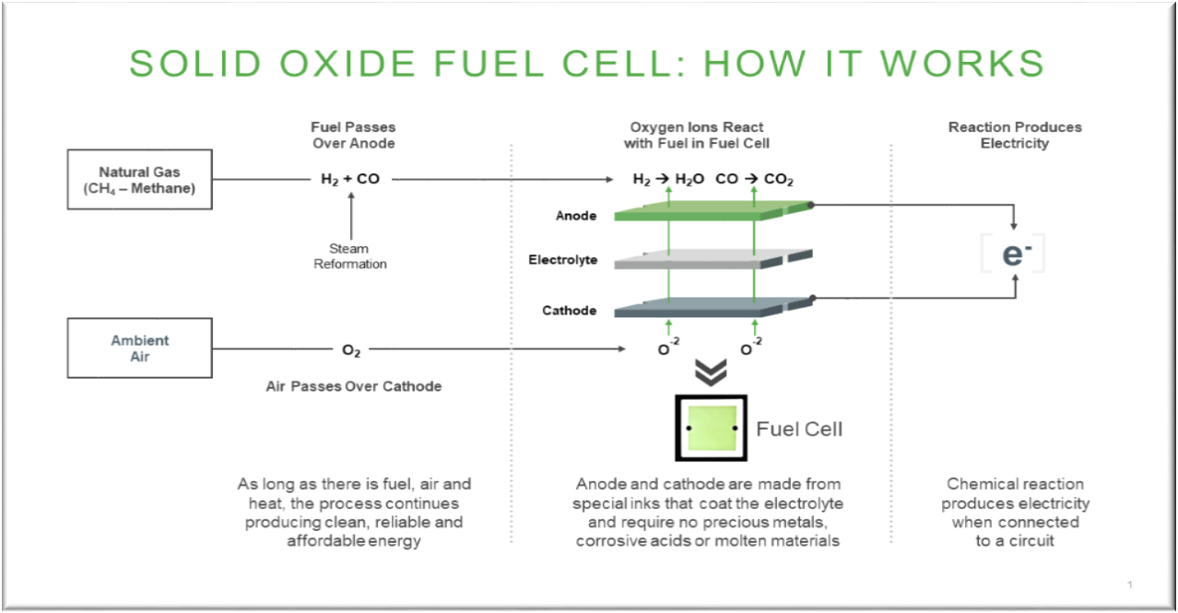

Working of SOFC

Fig. (9)

Working:

Reduction of oxygen into oxygen ions occurs at the cathode. These ions can then diffuse through the solid oxide electrolyte to the anode where they can electrochemically oxidize the fuel. In this reaction, a water byproduct is given off as well as two electrons. These electrons then flow through an external circuit where they can do work. The cycle then repeats as those electrons enter the cathode material again.

**1.3 Objective**

Create a mathematical Model and simulate using PYTHON to analyze the working of SOFC at various conditions.

1} Determine the I – V characteristic curve at different temperatures and different fuel flow rates.

2} Determine the Nernst Potentials at different temperatures.

3}Determine the Activation losses, Concentration losses and Ohmic losses at different temperatures.

4} Determine Power Curves at Different Tempertures and Different fuel flow rates.

5} Determine net output voltage at different temperatures and different fuel flow rates.

**1.4 Scope**

1)Rising Demand for Efficient and Clean Energy GenerationGlobally, the population is growing at a rapid pace, resulting in high demand for energy and power. Increasing automation, ongoing industrialization with global concern regarding the emissions is driving demand for the eco-friendly and energy efficient energy generation system.

2) The global solid oxide fuel cell market is growing on the grounds of favorable support through high investment in the SOFC by the government organizations worldwide. Low emission, higher efficiency for energy generation, relatively low cost, and various other advantages associated with the SOFC, are capable of reducing emission.

**1.5 Methodology**

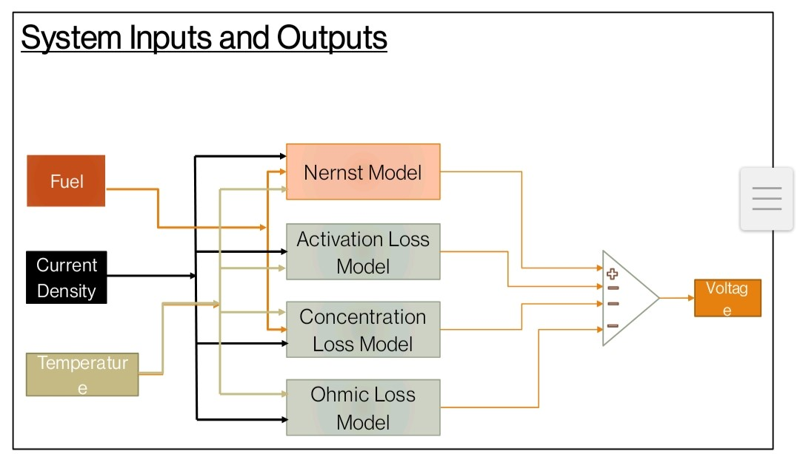

Fig. (10)

Solid oxide fuel cells offer great promise to generate energy from hydrocarbons. They convert the fuel chemical energy directly into the electrical energy through electrochemical reactions that are driven by the difference in the oxygen chemical potential between the anode and cathode of the cell.

The SOFC models developed thus far are mainly based on the Nernst equation, activation, ohmic, and concentration losses. This approach results in good agreement with experimental data and poor agreement for other than original experimental working parameters. Moreover, most of the equations used require the addition of numerous factors which are difficult or impossible to determine. Very detailed models are often characterized by relatively long times needed to find a solution for the used set of equations. Proper identification of all necessary factors and their impact on each other as well as on other parameters can often take a longer time and much more effort than later utilization of the model. Sometimes the task of preparing a model of the SOFC is disproportionately difficult relative to the calculations made subsequently. In practical applications, the complexity of the fuel cell model should not deviate greatly from the models of other devices that make up the whole power-generating module. On occasion, it is far more easier to use fully empirical models, e.g. based on an artificial neural network, than to make a model founded on basic principles, but of course this approach does not give any information about the main processes which occur during fuel operation.

**2 Literature Review**

1. Mathematical Modelling of Planar Solid Oxide Fuel Cells.

Jamie Ian Sandells**-**  School of Chemical Engineering The University of Birmingham August 2013

Importantant Outcome from Paper **–**

1. Clear Idea of SOFC, its structure and function – Generally, fuel cells consist of three layers which are two electrodes (the anode and cathode) on the outside of an electrolyte. The electrodes consist of a porous material which allows the fuel and oxidant to diffuse into the electrode. The electrolyte is made of a non-porous material to stop the fuel and oxidant mixing during the operation of the cell and to also conduct the charge carrier. Connecting the two electrodes is an interconnect which the produced electrons pass through to generate an electric current
2. Types of Fuel Cells and their differences -Fuel cell Abbreviation Mobile ion Operating Temperature

1. Polymer Electrolyte Fuel Cell PEMFC - H+ - 60-80◦C

2. Alkaline Fuel Cell AFC - OH - 50-200◦C

3. Phosphoric Acid Fuel Cell PAFC - H+ - 200◦C

4. Molten Carbonate Fuel Cell MCFC - CO−2 - 650◦C

5. Solid Oxide Fuel Cells SOFC - O−2 - 600-1000◦C

1. Reactions of SOFC –

Anode reaction within an SOFC is given by

H2 + O 2− → H2O + 2e –

Cathode reaction is

1/2 O2 + 2e − → O 2−

Full cell reaction

H2 + 1 2 O2 → H2O

1. Mathematical modelling of solid oxide fuel cell using MATLAB/Simulink **–**

By - TVVS Lakshmi, P Geethanjali and Krishna Prasad S School of Electrical

Engineering, VIT University, Vellore, Tamil Nadu, India

Published at - International Conference on Microelectronics, Communication and Renewable Energy (ICMiCR-2013)

Important Outcome from Paper **–**

1. In this paper transfer function model of Nernst reversible voltage and all the losses are included for modelling. Steady state response of single cell fuel cell is obtained at different flow rates and temperatures. It is observed that as the flow rate is increased, the limiting current value has also increased. The maximum limiting current is observed at fuel flow rate 51ml/sec. Results are validated from the experimental results in the reference paper
2. Formulae’s for following are Derived which can be used directly to find out and study the various parameters for solid oxide fuel cells- Net Voltage Output,Activation Loss, Ohmic Loss, Concentration Loss, Nernst Potentials, Partial Pressures for Hydrogen, Oxygen and Water, Exchange Current Density.
3. We also get Importantant values for some of the important constants that we use to solve the formulaes like – Molar gas valves for hydrogen, oxygen and water, Respnose time for hydrogen,oxygen and water etc.
4. Solid Oxide Fuel Cell Modeling **–**

By **-** AbrahamGebregergis, Member, IEEE, Pragasen Pillay, Fellow, IEEE, Debangsu Bhattacharyya, and RaghunathanRengaswemy

Presented at **-**IEEE TRANSACTIONS ON INDUSTRIAL ELECTRONICS, VOL. 56, NO. 1, JANUARY 2009

Important Outcomes from Paper **–**

1. A lumped model was discussed that can be extended to model fuel cell stacks for real-time applications. The basic governing equations of the fuel cell were modeled with equivalent electrical circuits in order to simplify the system and achieve flexibility and easy tuning. The steady-state simulation results of the lumped model agree with the experimental data and results of the distributed model. The capacitance in the simplified equivalent RC circuit can be changed to give the exact dynamic time response of the physical fuel cell. This SOFC model can be easily implemented in Matlab/Simulink and then programmed for real-time testing, which will help to study the performance of the fuel cell when subjected to external control.

2. Distributed Model The distributed- modeling approach is introduced here before discussing the lumped SOFC modeling. We also acknowledges with the Conservation equations in the channels for Distributed SOFC Models like Hydrogen conservation, Water conservation, Oxygen conservation also, The momentum conservation equations for the distributed SOFC model like Anode, Cathode momentum conservation equation

1. Modeling of Solid Oxide Fuel Cell/Gas Turbine Hybrid Systems **–**

By - Nischal Srivastava

Presented at - THE FLORIDA STATE UNIVERSITY FAMU-FSU COLLEGE OF ENGINEERING

Important outcomes from paper **–**

This thesis deals with solid oxide fuel cell and gas turbine hybrid systems.

Hybrid systems combine two or more power generating devices and make use of the synergism to generate maximum power and offer higher efficiencies. Hybrid systems typically present low combustion temperature resulting in low exhaust temperature and zero or low level of nitrogen oxides. The exhaust of a high temperature fuel cell can be expanded in a gas turbine to drive a compressor, which in turn provides pressurized streams to the fuel cell. The residual enthalpy can be used in other turbine stages resulting in additional power. There are several configurations in which a fuel cell and a gas turbine can be arranged as a cycle. shows a particular configuration of a micro GT/SOFC hybrid system. The air stream is pressurized in a compressor and passes through a recuperator where it is preheated. The fuel stream from the pump and the air stream from the recuperator enter the SOFC. Within the fuel cell, fuel and air react electrochemically to generate electricity and a high enthalpy exhaust. This high enthalpy exhaust is mixed with bypassed air stream from the recuperator and combusted in an oxidizer. This high temperature and high pressure effluent is now expanded in the turbine to provide work to drive the compressor and an electrical generator. In this way, the waste heat from the fuel cell is utilized to increase the system efficiency.

1. Modeling and Simulation of Solid Oxide Fuel Cell Based Distributed Generation System **–**

By - Mukesh Kumar Baliwal, Dr.A.Bhargava, Mr. S.N. Joshi,SunilkumarM.Tech Scholar (Power Systems), Dept. of Electrical Engineering, UCE-RTU Kota (Rajasthan). Associate Professor, Dept. of Electrical Engineering, UCE-RTU Kota (Rajasthan),Assistant Professor& HOD, Dept. of Electrical Engineering, -GWEC, Ajmer (Rajasthan)

Presented at - International Journal of Engineering Research & Technology (IJERT) Vol. 2 Issue 8, August - 2013 IJERT ISSN: 2278-0181

Important outcomes from Paper **–**

This paper shows the impact of fuel cell power system on the stability of power system. The dynamic modeling and simulation results of a fuel cell based power system which consists of solid oxide fuel cell (SOFC) for power generation. The SOFC modeled individually and latterly integrate in Matlab/Simulink software. The developed Simulink model of fuel cell system is then connected to 11Kv grid through an AC bus. . Simulation studies have been carried out to verify the system performance under faulty condition.

1. Computational modeling of the transport and electrochemical phenomena in solid oxide fuel cells

By **-** Hocine. Mahcenea ,Hocine Ben Moussab , Hamza. Bouguettaiaa ,Djamel. Bechkia ,MostefaZeroualc

Presented at **-** Laboratory of New and Renewable Energy (LENREZA), P.O.Box 511, Ouargla University 30000 Algeria, Department macaque, University Batna, Algeria Department physics, University Algeria

Important outcomes from Paper **–**

This paper has presented a computational simulation of the transport and electrochemical phenomena in a planar SOFC. Significant results about the local transport characteristics inside the planar SOFC, such as the steam water, hydrogen and the temperature distributions, under various losses, operating conditions and different values of thickness have been presented. The unique features of this model are the implementation of the voltage-to-current algorithm and the coupling of the potential field with the reactant species concentration field, which allows for a more realistic spatial variation of the electrochemical kinetics. The results of this numerical thermodynamic–electrical model, solved by finite volume method and resolved by self-programming , show the effect of the heat sources as the temperature changes. Furthermore, hydrogen mass transfer is function of the anode thickness

We observe the study of following factors in this paper

1. Effect of anode thickness
2. Effect of various losses on the cell performance
3. Effect of fuel flow rate on the cell performance
4. Effect of operating pressure on SOFC performance
5. Modelling of a High Temperature Solid Oxide Fuel Cell **–**

By - Pankaj Kalra, Rajeev Garg, Ajay Kumar Dept. of Chem. Engg., Shaheed Bhagat Singh State Technical Campus, Ferozepur, Punjab, India, Dept. of App. Sci. &Hum.,ShaheedBhagat Singh State Technical Campus, Ferozepur, Punjab, India

Presented at - Journal of Energy Technologies and Policy www.iiste.org ISSN 2224-3232 (Paper) ISSN 2225-0573 (Online) Vol.5

Important outcomes from Paper **–**

A one - dimensional model was developed to comprehensively describe the electrochemistry, hydrodynamics and multi-component transport of SOFC. The model would be implemented into the commercial CFD software Ansys Fluent.

The CFD model would to be able to predict the current-voltage characteristics of SOFC, in addition to the detailed reactant and product distributions in the cell. This data makes it possible to analyze SOFC operation in detail.The CFD model described in this study is intended to present a tool for design optimization of SOFCs. To achieve this and fully utilize this tool, the model can be used to perform parametric and sensitivity studies of varying operating conditions and cell designs.

The present CFD model also has the energy equation built in to resolve the temperature distribution. However, a detailed account of various heat generating sources such as irreversible and reversible (entropic) heat as well as ohmic heating has not been accounted in the equations. The temperature distribution can be used to couple to stress analyses, thereby providing a comprehensive computer-aided engineering (CAE) tool for SOFC design and operation. The present model can be easily extended to include multiple fuels such as H2 and CO. Finally, the present model would serves as a building block to build a comprehensive CFD-based model for 3- dimensional SOFC with internal reforming on the anode. In such a situation, convectional & diffusional transport of various chemical species in all the three dimensional have to be taken into account

1. STEADY STATE MATHEMATICAL MODELING OF SOLID OXIDE FUEL CELL FOR HYBRID SYSTEM OF FUEL CELL AND GAS TURBINE (FC-GT)

By - DhananjaySahu ,Brijesh Patel

Presented at - Volume 6, Issue 6, June (2015), Pp. 12-17 Article ID: 20120150606003 International Journal of Advanced Research in Engineering and Technology (IJARET) © IAEME: www.iaeme.com/ ijaret.asp ISSN 0976 - 6480 (Print) ISSN 0976 - 6499 (Online)

Important outcomes from Paper **–**

The modeling of Solid Oxide Fuel Cell is done with consideration of almost all factor losses like activation losses, Ohmic losses, and concentration (diffusion) losses. And the equation for power output and the system efficiency is mathematically developed. Still modeling for fuel reformer and other component like compressor, recuperator, and combustor of hybrid system is to be carried out. This is supposed have huge area of modeling and other consideration with need of some practical assumptions

1. Mathematical modeling of solid oxide fuel cells: A review

By **-** S.Ahmad, A.shamiri

Important outcomes from Paper **–**

This paper presents a review of studies on mathematical modeling of solid oxide fuel cells (SOFCs) with respect to the tubular and planar configurations. In this work, both configurations are divided into five subsystem and the factors

1. Simulation of Solid Oxide Fuel Cell Anode in Aspen HYSYS—A Study on the Effect of Reforming Activity on Distributed Performance Profiles, Carbon Formation, and Anode Oxidation Risk

ByKhaliq Ahmed AmirpiranAmiri

Important outcomes from Paper **–**

A distributed variable model for solid oxide fuel cell (SOFC), with internal fuel reforming on the anode, has been developed in Aspen HYSYS. The proposed model accounts for the complex and interactive mechanisms involved in the SOFC operation through a mathematically viable and numerically fast modeling framework. Distributed variables including temperature, current density, and concentration profiles along the cell length, have been discussed for various reforming activity rates.

1. Modeling and simulation of grid connected solid oxide fuel cell using PSCAD

By **-** S.Fedakar , S.Bahceci, and  T.Yalcinoz

Important outcomes from Paper **–**

In this paper, a grid connected SOFC system is presented by using PSCAD software. The power conditioning unit (PCU) is used for simulation studies and also the transformer is used for electrical isolation. The simulation studies of the SOFC dynamic model are investigated for three case studies.The results show the fast response capabilities of the grid connected SOFC system in different case studies and various load types.

1. Dynamic modeling and simulation of Solid Oxide Fuel Cell system

By **-**A.A.Salam; M.A.Hannan ; A.Mohamed

Important outcomes from Paper **–**

This paper deals with the modeling and analysis of dynamic model of solid oxide fuel cell (SOFC) system in response to the grid connection using PSCAD/EMTDC simulation software. The designed controller is also implemented to analyzed the output response of the developed fuel cell that can be used in distributed generation applications.

1. Modelling and Simulation of Solid Oxide Fuel Cell

By **-**Ruchi Yadav Gauri Shankar

Important outcomes from Paper **–**

This paper focuses on the study of fuel cells as a renewable source of energy which is environment friendly and much more consistent in performance as compared to solar and wind energy. This paper deals with the study of dynamic model of solid oxide fuel cell (SOFC) based on transfer function. The studied model includes the effect of activation, ohmic and concentration losses on the dynamic performances of SOFC.

1. Review of Solid Oxide Fuel Cell Materials : cathode, anode, and electrolyte By **–** Saddam Husain, Li Yangping

Imprtant outcomes from Paper **–** This Paper focuses on the overview of the SOFCs devices and their related materials and mostly reviewed newly available reported.

In this Paper to summarized both types of SOFCs electrodes such as cathode and anode and their importance in SOFCs technology.

It has been reviewed that nanomaterials easily enhanced the performance of SOFCs devices. There is much more attention need to develop a higher performance of nanostructure materials which can be operated at low temperature. This will increase the importance of SOFCs technology. However, cost reduction is still a key problem in SOFCs technology.

1. Morphological of Yttrium Stabilized Zirconia (YSZ) Thin Film of Electrolyte in Solid Oxide Fuel Cell Application By– N.F.M. Rahimi, YussofWahab, Rosnita Muhammad

Important outcomes from Paper **–**

1. The performance of solid oxide fuel cell is focused on lowering operating temperature (400°C-650°C). To achieve the goal, the thickness of commonly used electrolyte, YSZ was reduced.
2. The dip-coating technique was used for preparing dense YSZ electrolyte thin films on glass substrate. The suspensions were prepared by sol-gel method. Polyvinyl alcohol (PVA) and polyethylene glycol (PEG) was used as a ceramic binder and plasticizer, respectively.
3. Crystalline structure and morphology of thin films were analyze by X-ray diffraction (XRD) and Atomic Force Microscope (AFM). The XRD reveals that crystallization of YSZ phase does not occur at any sintering temperature but can only have a small peak at 2θ = 30° as the thickness of layer increase. The roughness and morphology of the film with different thickness were observed. The roughness increased as the thickness increased.
4. A Review of the Importance and Present Status of Micro-Tubular Solid Oxide Fuel Cells By**-**  Md. Hasan Zahir

Important outcomes from Paper **–**

1. The generation of environmental-friendly energy is now one of the major demand of the world for healthy future. Fuel cell is one of the prime candidate in this regard which convert chemical energy of a fuel gas very efficiently and directly into electrical energy.
2. This Paper describes the concept, impact of anode and electrolyte morphology, thickness, diameter, and fabrication of a micro-tubular solid oxide fuel cell (SOFC). The Paper describes the anode, cathode, and electrolyte of the cell components in more detail and their importance of each is regarding their size and thickness. Advantages of micro-tubular SOFCs with respect to the other fuel cell technologies are compared.
3. This paper describes the potential for directly running off hydrocarbon fuels and the design and operation of micro-tubular SOFCs on bio-fuel specifications and materials’ requirements. The paper also discuss fabrication technology of micro-tubular single cell by using commercially available raw materials.
4. Solid Oxide Fuel Cell By – Subhash C. Singhal

Important outcomes from Paper **–**

1. This paper describes activity in the development of SOFCs capable of operating in the temperature range of 650 to 800oC has increased dramatically in the last few years. However, at lower temperatures, electrolyte conductivity and electrode kinetics decrease significantly; to overcome these drawbacks, alternative cell materials and designs are being extensively investigated.
2. The single biggest advantage of tubular cells over planar cells is that they do not require any high temperature seals to isolate oxidant from the fuel, and this makes performance of tubular cell stacks very stable over long periods of times (several years).
3. The challenge in successfully commercializing SOFCs offering high power densities and long term durability requires reduction of costs associated with the cells and the balance-of-plant. Additionally, for transportation APU applications, ability for rapid start up and thermal cycling needs to be developed
4. Modelling a Solid Oxide Fuel Cell with Infiltrated Electrodes By– Rustam Singh Shekhar, Antonio Bertei, Dayadeep S. Monder

Important outcome from this Paper -

1. The microstructure of a solid oxide fuel cell (SOFC) electrode has a direct impact on its transport and kinetic properties, which in turn control electrode and cell performance. This study presents models and simulations for SOFC performance that use previously published models to describe the connection between electrode microstructure and key properties such as effective conductivity, three phase boundary density, effective diffusivity, and permeability.
2. These effective properties are then used in a multiphysics model that solves the coupled set of differential equations that describe the working of a SOFC for a given set of operating conditions and model parameters. The results presented strongly suggest that using infiltrated electrodes for both the air and fuel electrodes, instead of conventional composite sintered-powder based electrodes, leads to substantially higher performance as measured by high current density at high cell potentials and high fuel utilization.
3. The cell performance curves are supplemented with sensitivity and parametric analyses to examine the impact of varying experimentally controllable electrode microstructural parameters on cell performance.

**CHAPTER 3**

**MATHEMATICAL MODELING**

1)Nernst Voltage:

The Nernst reversible voltage is the open-circuit voltage of the SO fuel cell when the current density *I*fc is zero.

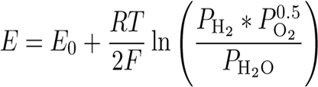

Where,

E0 = 1.1 V is the standard potential

R = 8.314 kJ/ kmol .K is the universal gas constant

T = operating temperature of the fuel cell in kelvins

F = 96486 C/mol is the Faraday constant

2)Activation Loss:

Chemical reactions, including electrochemical reactions, must overcome energy barriers, called “activation energy,” for the reaction to proceed. This leads to activation polarization. The activation loss is given by the Butler–Volmer equation

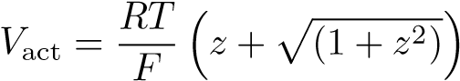

Where ,

I0 is the exchange current

αi is the coefficient of charge transfer

n = 2 is the number of moles of electrons transferred

3)Concentration loss:

This occurs due to the mass transfer resistance to the flow of the reactants and the products through the porous electrodes. Concentration voltage loss can be calculated as,

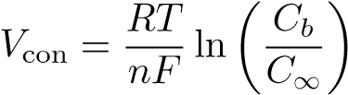

Where,

Cb is the concentration at the triple-phase boundary (tbp) where the gas, electrolyte,

C∞ is the bulk concentration of reactant

n is the number of moles of electrons participating in the reaction

4)Ohmic Loss:

Ohmic losses occur because of the resistance to the flow of ions in the electrolyte and the resistance to the flow of electrons through the electrode.

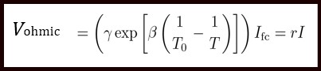

where

T is the fuel cell temperature

T0 = 973 K

γ = 0.2 Ω, and β = −2870 K are the constant coefficients of the fuel cell

r is the internal resistance of the SOFC.

5)Net Output Voltage:

Net output voltage is the quantity we get when we subtract all losses (Activation Loss, Ohmic Loss, Concentration Loss) from Nernst voltage.

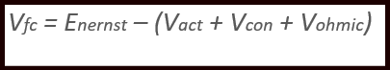

6)Partial Pressures:

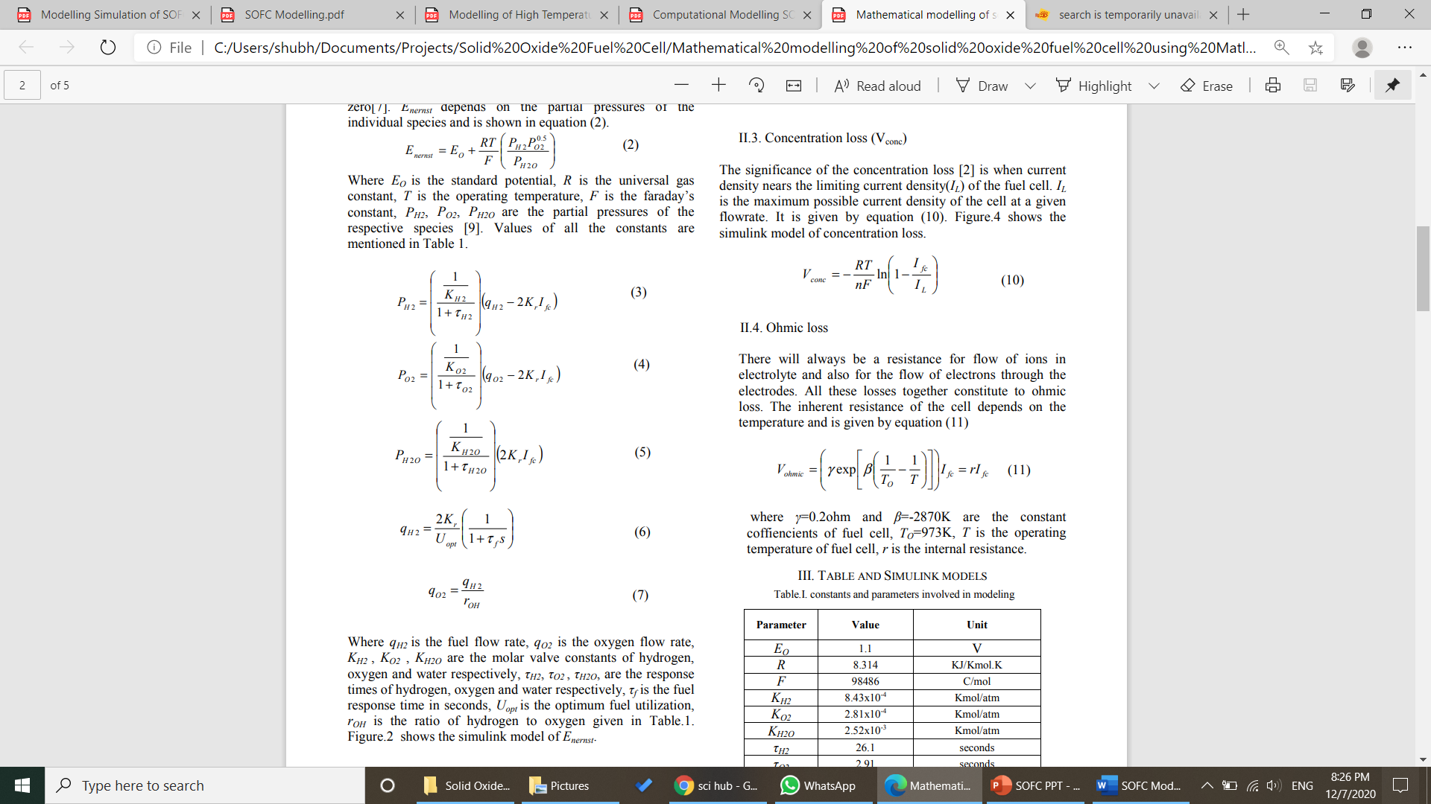

Where

qH2 is the fuel flow rate

qO2 is the oxygen flow rate

KH2 , KO2 , KH2O are the molar valve constants of hydrogen, oxygen and water respectively,

τH2, τO2 , τH2O, are the response times of hydrogen, oxygen and water respectively,

τf is the fuel response time in seconds,

Uopt is the optimum fuel utilization,

rOH is the ratio of hydrogen to oxygen

7)Output Currents:

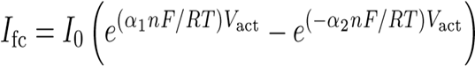

Where,

I0 is the exchange current

αi is the coefficient of charge transfer

n = 2 is the number of moles of electrons transferred



Where,

A = 101.2 kA/cm2 is a preexponential factor obtained by curve fitting with the distributed model

Eact = 120 kJ/mol is the activation energy of the electrochemical reaction.

**CHAPTER 4**

**Results and Discussion:**

1) Nernst Voltage:

Table (1) Fig. (11)

2) Activation Loss:

Table (2) Fig. (12)

3) Concentration Loss:

Table (3) Fig. (13)

4)Ohmic Loss:

Table (4) Fig. (14)

5) Output Voltage:

Table (5) Fig. (15)

6) Power Vs Temperature:

Table (6) Fig. (16)

Overall Results For Different Fuel Flow Rates:

1. Fuel Flow Rate 25ml/sec.

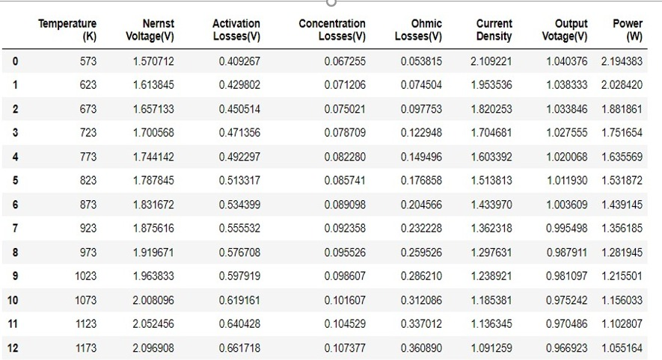

Table (7)

1. Fuel Flow Rate 50ml/sec.

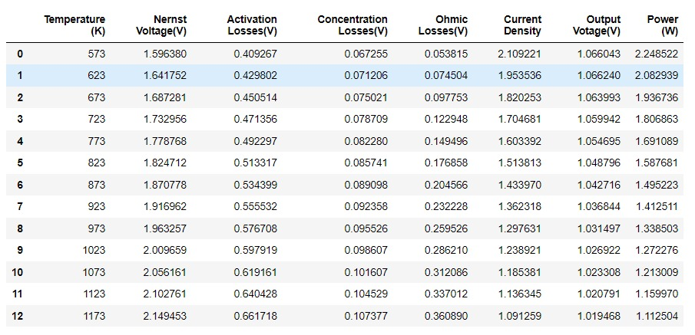

Table (8)

3) Fuel Flow Rate 75ml/sec.

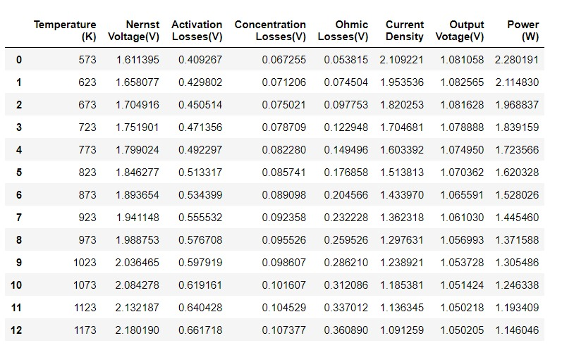

Table (9)

**CHAPTER 5**

**Experimental Validation :**

|  |  |  |  |  |  |  |
| --- | --- | --- | --- | --- | --- | --- |
| Temperature | Reference Voltage | Voltage | Reference Current | Current | Reference Power | Power |
| 873 | 1.001 | 1.003 | 1.41 | 1.43 | 1.41 | 1.4391 |
| 923 | 0.95 | 0.99 | 1.28 | 1.36 | 1.28 | 1.3561 |
| 973 | 0.92 | 0.9879 | 1.16 | 1.29 | 0.94 | 1.2155 |
| 1023 | 0.89 | 0.9610 | 1.10 | 1.2 | 0.94 | 1.2155 |
| 1073 | 0.7 | 0.9752 | 1.02 | 1.18 | 0.82 | 1.1560 |

Table (10)

Reference of Validation:

1. A New type of SOFC for conversion of High Temperature heat to electricity without carnot limitation

Author :Kallarackel Thomas Jacob

1. Understanding the Current-Voltage behaviour of high temperature Solid Oxide Fuel Cell Stacks

Author : M. Lang, C. Bohn, M. Henke, G. Schiller, C. Willich and F. Hauler

**CHAPTER 6**

**CONCLUSION AND FUTURE SCOPE:**

**a)Future Scope**

SOFC have a number of advantages as mentioned below:

Since all the components are solid, as a result, there is no need for electrolyte loss maintenance and also electrode corrosion is eliminated.

Since SOFCs are operated at high temperature, expensive catalysts such as platinum or ruthenium are totally avoided.

Also because of high-temperature operation, the SOFC has a better ability to tolerate the presence of impurities as a result of life increasing.

Costs are reduced for internal reforming of natural gas.

Due to high-quality waste heat for cogeneration applications and low activation losses, the efficiency for electricity production is greater than 50¹ªand even possible to reach .

Releasing negligible pollution is also a commendable reason why SOFCs are popular today

Because of these advantages both the public and private sectors benefit from working together on SOFC development. The public sector gains a cost-effective and efficient method of fulfilling its mission to help the nation develop clean and affordable energy from domestic fuel resources. The private sector gains access to funding and academic research that initiates market entry.

Following are the areas where SOFC can make difference:

1. Integating solid oxide fuel cell with gas turbines - Mitsubishi has developed a way to integrate SOFC with micro gas turbines . In this system fuel gas is inserted into the SOFC to generate power and high temperature exhaust gases from SOFC are inserted into gas turbine to get additional power . Heat is removed from high temperature exhaust gases to produce heated water . This is very promising technology.

2. Combined heat and power generation – Combined heat and power SOFC are well suited to stationary power generation for residential as well as business spaces . SOFC’s high temperatures make them efficient for CHP system , as waste can be put to a good use of heating and cooling.

3.Power source for large scale industries – Large scale systems can be used at whole building level or for industrial applications for power entire factory to keeping machinery cool .

4.Powering the EV’s – Nissan automobile is currently using this technology . SOFC’s are finding uses in larger vehicles as range extenders for battery electric vehicles , converting fuel as ethanol into electricity which can charge car battery even when driving and avoid the need for time consuming charging process. The emission caused by this is as little as zero .

5.Producing electricity from biogas – SOFC’s were used in the system to produce electricity from biogas in a shrimp farm located in Ben Tre , Vietnam in 2017 . More exploration is needed in this area .

6.Reversible SOFC to produce Hydrogen - In reverse mode when power is applied to the cell, the SOFC acts as an electrolyzer and produces chemicals such as hydrogen through steam electrolysis. Currently U.S. Department of Energy is working on this system .

b)**Conclusion**

There are many factors which affect the performance of Solid Oxide Fuel Cell like material used for anode & cathode, fuel used, temperature of operation. We have studied the effect of temperature range on different parameters of Solid Oxide Fuel Cell.

Based on the conducted research, the following conclusion can be drawn:

1. Values for Nernst Voltage varies from 1.5 V to 2.5 V for 573 K to 1173 K temperature range. It shows us with the increase in temperature value of voltage is decreasing.
2. Activation losses voltage varies from 0.4 V to 0.7 V for 573 K to 1173 K temperature range. Activation loss is increasing with increase in temperature.
3. Concentration losses Voltage varies from 0.06 V to 0.11 V for the given temperature range. It shows concentration losses increases with increase in temperature.
4. Ohmic losses voltage varies from 0.05 V to 0.37 V for the temperature range taken. It shows increase in ohmic loss with the increasing temperature.
5. Net output voltage decrease with the increase in temperature. It varies from 1.04 V to 0.96 V for the given temperature range i.e. 573 K to 1173 K.
6. Power output decreases with increase in the temperature.
7. The mathematical & computational scheme proposed in this papers gives measures for different losses, output voltage, power & current density under dynamic operating temperature ranges.

**References**

1. Saikia, Kaustav; Kakati, Biraj Kumar; Boro, Bibha; Verma, Anil (2018). "Current Advances and Applications of Fuel Cell Technologies"
2. Khurmi, R. S. (2014) S. Chand & Company . Material science.
3. Schmidt-Rohr, K. (2018). "How Batteries Store and Release Energy: Explaining Basic Electrochemistry"
4. Advances in solid oxide fuel cell technology - S.C. Singhal
5. An Octane-Fueled Solid Oxide Fuel Cell - Zhongliang Zhan and Scott A. Barnett
6. A Low-Operating-TemperatureSolid Oxide Fuel Cell inHydrocarbon-Air Mixtures - Takashi Hibino, Atsuko Hashimoto, Takao Yoshida, Mitsuru Sano
7. The London and Edinburgh Philosophical Magazine and Journal of Science. 1838.
8. Grove, William Robert (1839). "On Voltaic Series and the Combination of Gases by Platinum"
9. The London and Edinburgh Philosophical Magazine and Journal of Science.
10. Solid oxide fuel cell technology—features and applications - *Nguyen Q. Minh*
11. Cu-Ni Cermet Anodes for Direct Oxidation of Methane in Solid-Oxide Fuel Cells - H. Kim, C.Lub, W. L. Worrell,J. M. Vohs
12. "The Brits who bolstered the Moon landings"-BBC
13. Fuel Cell Handbook Fourth Edition By- J.H. Hirschenhofer, D.B. Stauffer, R.R. Engleman, and M.G. Klett
14. Anne-Claire Dupuis, Progress in Materials Science, Volume 56, Issue 3, March 2011
15. Measuring the relative efficiency of hydrogen energy technologies for implementing the hydrogen economy 2010 - 5 November 2013
16. Ballard Power Systems: Commercially Viable Fuel Cell Stack Technology Ready by 2010
17. Y. Wang, Ken S. Chen, Jeffrey Mishler, Sung Chan Cho, Xavier Cordobes Adroher, A Review of Polymer Electrolyte Membrane Fuel Cells: Technology, Applications, and Needs on Fundamental Research, Applied Energy
18. Fuel Cells: Technologies and Applications Leonardo Giorgi1,* and Fabio Leccese2,* Via Mantova n.11, Anzio, Italy Science Department, University of “Roma Tree
19. A Comparative Study between the Seven Types of Fuel CellsFiseha M. Guangul*Department of Mechanical Engineering, Middle East College, Muscat, OmanGirma T. ChalaInternational College of Engineering and Management, Muscat, Oman
20. "Fuel Cell Project: PEM Fuel Cells photo "
21. "Collecting the History of Proton Exchange Membrane Fuel Cells"
22. International Association for Hydrogen Energy. Retrieved 8 March 2011.
23. Parametric energy analysis of a tubular solid oxide fuel cell stack through finite-volume model By – F. Calise, Ferruzzi G., Vanoli L.
24. "The PureCell Model 400 – Product Overview" by UTC power
25. Analytical Modelling of Fuel Cells. 1st edition, Elsevier, ISBN 9780444535603 By – A. Kulikovsky
26. An improved one-dimensional membrane-electrode assembly model to predict the performance of solid oxide fuel cell including the limiting current density. Journal of power sources, By – Lee W. , Wee D. , Ghoniem A.
27. Transport, chemical and electrochemical processes in a planar solid oxide fuel cell By – Kosinski P., Hoffman A., Vikb A.
28. Reviewing the mathematical validity of a fuel cell cathode model. Existence of weak bounded solution By – Al-arydah M., Carraro T.
29. Comprehensive understanding of the active thickness in solid oxide fuel cell anodes using experimental, numerical and semi-analytical approach By – Miyawaki K., Kishimoto M., Iwai H., Saito M., Yoshida H.
30. Modelling a Solid Oxide Fuel Cell with Infiltrated Electrodes By– Rustam Singh Shekhar, Antonio Bertei, Dayadeep S. Monder
31. A Review of the Importance and Present Status of Micro-Tubular Solid Oxide Fuel Cells By**-**  Md. Hasan Zahir

**Annexure**

**Modelling Of SOFC**[**¶**](http://localhost:8888/notebooks/Documents/Data%20Science/Project%20-%2002.%20Mathematical%20Modelling%20of%20Solid%20Oxide%20Fuel%20Cell/SOFC%20Modelling.ipynb#Modelling-Of-SOFC) **in Python Code**

**1. Variation in Activation Losses 2. Variation in Ohmic Losses**

**3. Variation in Concetration Losses 4. Variation in Nenrst Voltage**

**5. Variation in Output Voltage 6. Variation in Power Output**

**7. Voltage-Current variations**

**Importing Python libraries required for Mathematical Calculations and Visualisation**

import math

import matplotlib.pyplot as plt

import pandas as pd

import numpy as np

import seaborn as sns

%matplotlib inline

sns.set_style('darkgrid')

plt.rcParams['font.size'] = 14

plt.rcParams['figure.figsize'] = (9, 5)

plt.rcParams['figure.facecolor'] = '#00000000'

# Constants used in Model

I_L = 0.14806 #input("Maximum Current density") # Maximum current that can flow (10 A)

I0 = 2.00 #input("Exchange Current") # Exchange Current (say 2 A)

V_act = 0.1 #input("Activation Loss") # Activation Loss Not known(say 1)

r = 5.00 #input("Internal Resistance") # Internal Resistance of SOFC(say 10 Ohm)

Y = 0.200 # Constant used in Ohmic Losses

B = 2870.0 # Constant used in Ohmic Losses

T0 = 973.0 # Constant in K

E0 = 1.1 # 1.1V Standerd Potential

R = 8.31400 # Univeral Gas Constant in (J/mol-K)

F = 96486.0 # Faradays Constant

alpha1 = 0.1 # Approximate 0.1

alpha2 = 0.2 # Approximate 0.1

n = 2.0 # No. o moles

# Molar Valve constants for Hydrogen, Oxygen and Water

Kh2 = 0.843

Ko2 = 0.281

Kh2o = 2.52

# Response time for Hydrogen, Oxygen and Water

Th2 = 26.10

To2 = 2.91

Th2o = 78.3

Kr = 1.0/(8.0*F)

**1. Inputs - Fuel Flow Rates**

## qh2- Flow rate of Hydrogen

## qo2- Flow rate of Oxygen

I_fc_list =[]

for T in t :

first_term = np.exp((alpha1*n*F/(R*T))*V_act)

second_term = np.exp((-alpha2*n*F/(R*T))*V_act)

I_fc = I0*(first_term - second_term)

I_fc_list.append(I_fc)

I_fc = 1.1459

print(I_fc_list)

pd.DataFrame({"Output Current":I_fc_list})

# 2. Output Current Density (I_fc )

### I0 is the exchange current

### αi is the coefficient of charge transfer

### n = 2 is the number of moles of electrons transferrer

qh2 = 25.0 #[*np.arange(35.0, 50.0 , 2)]

qo2 = 25.0 #[*np.arange(35.0, 50.0 , 2)]

t = [*np.arange(573,1223,50)]

print("Fuel flow Rate in ml/sec for Oxygen - ")

print(qh2)

print("Fuel flow Rate in ml/sec for Hydrogen - ")

print(qh2)

pd.DataFrame({"Temperature":t})

# 3. Partial Pressures

### •qH2 is the fuel flow rate

### •qO2is the oxygen flow rate

### •KH2,KO2,KH2O are the molar valve constants of hydrogen, oxygen and water respectively,

### •τH2,τO2,τH2O, are the response times of hydrogen, oxygen and water respectively,

### •τf is the fuel response time in seconds,

### •Uopt is the optimum fuel utilization,

Ph2_list = []

Po2_list = []

Ph2o_list = []

for I_fc in I_fc_list:

item1 = ((1/Kh2)/(1+Th2))*(qh2 - 2*Kr*I_fc)

Ph2_list.append(item1)

for I_fc in I_fc_list:

item2 = ((1/Ko2)/(1+To2))*(qo2 - 2*Kr*I_fc)

Po2_list.append(item2)

for I_fc in I_fc_list:

x = (1/Kh2o)

y = (1+Th2o)

z = (2*Kr*I_fc)

item3 = (x)/(y)*(z)

Ph2o_list.append(item3)

partial_pressure_vs_I_fc = pd.DataFrame({

"I_fc Current":I_fc_list,

"Ph2 - PP of Hydrogen" : Ph2_list,

"Po2 - PP of Oxygen" : Po2_list,

"Ph2o - PP of Water" : Ph2o_list,

})

print(partial_pressure_vs_I_fc )

# 4. Nernst Equation For (E_nernst)

# E0 = 1.1 V is the standard potential

# R = 8.314 kJ/ kmol .K is the universal gas constant

# T = operating temperature of the fuel cell in kelvins

# F = 96486 C/mol is the Faraday constant

E_nernst = []

for T,Ph2,Po2,Ph2o in zip(t,Ph2_list,Po2_list,Ph2o_list):

item = (E0 + (R*T/(2*F))*(math.log((Ph2*math.pow(Po2,0.5))/Ph2o)))

E_nernst.append(item)

Temp_vs_Enernst = pd.DataFrame({

"Temperature in K":t,

"Nernst Voltage in V" : E_nernst,

})

print(Temp_vs_Enernst)

plt.figure(figsize=(12,8)

plt.plot(t,E_nernst)

plt.xlabel('Temp K')

plt.ylabel('voltage (mV)')

plt.grid(True)

plt.show()

# 5. Activation Losses

### I0 is the exchange current

### αi is the coefficient of charge transfer

### n = 2 is the number of moles of electrons transferred.

V_act = []

for T,I_fc in zip(t,I_fc_list):

z = I_fc/(2.0*I0)

item = ((R*T)/(2*alpha1*F))*(z+math.sqrt(1+math.pow(z,2)))

V_act.append(item)

Temp_vs_Vact = pd.DataFrame({

"Temperatures in K":t,

"Activation Losses in V" : V_act,

})

print(Temp_vs_Vact)

plt.figure(figsize=(8,5))

plt.plot(t, V_act)

plt.xlabel("Temperatures in K")

plt.ylabel("Activation Losses in V")

plt.show()

# 6. Concentration Losses

### Cb is the concentration at the triple-phase boundary (tbp) where the gas, electrolyte,

### C∞ is the bulk concentration of reactant

### n is the number of moles of electrons participating in the reaction

### I L is the maximum possible current density of the cell at a given flowrate

### I fc is the given current density

# \

V_conc = []

for T,I_fc in zip(t,I_fc_list):

item = (R*T/(n*F))*(math.log(1+(I_fc/I_L)))

V_conc.append(item)

Temp_vs_Vconc = pd.DataFrame({

"Temperature":t,

"Concentration Losses in V" : V_conc,

})

print(Temp_vs_Vconc)

plt.figure(figsize=(12,8))

plt.plot(t,V_conc)

plt.xlabel("Temperatures in K")

plt.ylabel("Concentration Losses in V")

plt.show()

# 7. Ohmic Losses

### T is the fuel cell temperature

### T0 = 973 K

### γ = 0.2 Ω, and β = −2870 K are the constant coefficients of the fuel cell

### r is the internal resistance of the SOFC

V_ohmic = []

for T,I_fc in zip(t,I_fc_list):

item = (Y*(np.exp(B*((1/T0)-(1/T)))))*I_fc

V_ohmic.append(item)

Temp_vs_Vohm = pd.DataFrame({

"Temperature":t,

"Ohmic Losses in V" : V_ohmic,

})

print(Temp_vs_Vohm)

plt.figure(figsize=(12,8))

plt.plot(t,V_ohmic)

plt.xlabel("Temperatures in K")

plt.ylabel("Ohmic Losses in V")

plt.show()

### 8. Net Output Voltage

## Output Voltage = Nernst Voltage – (Activation Loss + Concentration loss + Ohmic Loss)

## V_out = E_nernst – (V_act + V_con + V_ohmic)

a = np.add(V_ohmic, V_conc)

b = np.add(a,V_act)

V_out = np.subtract(E_nernst, b)

Temp_vs_V_out = pd.DataFrame({

"Temperature":t,

"Output Voltage in V" : V_out,

})

# 9. Power in SOFC

power = []

for Ifc, Vout in zip(I_fc_list,V_out):

power.append(Ifc*Vout)

Temp_vs_power = pd.DataFrame({

"Temperature":t,

"Power" : power,

})

print(Temp_vs_power)

plt.figure(figsize=(12,8))

plt.plot(t,power)

plt.xlabel("Temperatures in K")

plt.ylabel("Power in W")

plt.show()

plt.figure(figsize=(15,8))

plt.plot(t,E_nernst, label="Nernst Potenstial")

plt.plot(t, V_act, label="Avtivation Losses")

plt.plot(t,V_conc, label="Concentration Losses")

plt.plot(t,V_ohmic, label="Ohmic Losses")

plt.plot(t,V_out, label="Output Voltage")

plt.xlabel("Temperatures in K")

plt.ylabel("Voltage in V")

plt.legend()

plt.show()

# Summary

# Voltages vs Temperature

## Current vs Voltage

plt.figure(figsize=(12,8))

plt.plot(I_fc_list,V_out)

plt.xlabel('Current in A')

plt.ylabel('Output Voltage in V')

plt.show()

## Power vs Temperature

plt.figure(figsize=(12,8))

plt.plot(t,power)

plt.xlabel('Temperature in K')

plt.ylabel('Power in W')

plt.show()